

**Q.1 What is JavaScript. How to use it?**

**-** JavaScript is a high-level, interpreted programming language commonly used to create and control dynamic website content, such as animated graphics, interactive forms, and other user-interactive features.

**Q.2 How many types of Variables in JavaScript?**

- There are 3 types of variables in JavaScript. 1) Var 2) Let 3) Const

**Q.3 Define a Data Types in JavaScript?**

-There are 8 types primitive Data Types in JS.

1) String.

**(let name = 'Alice')**

2) Number

**(let age = 25)**

3) Boolean

**(let isJavaScriptFun = true, let isTired = false)**

4) BigInt

**(let bigInt = 1234567890123456789012345678901234567890n)**

5) Symbol

**(let sym = Symbol('description'))**

6) Undefine

**(let x; console.log(x))**

7) Null

**(let y = null)**

**Q.4 Write a mul Function Which will Work Properly When invoked With Following Syntax.**  
-Syntax is not provided

**Q.5 What the deference between undefined and undeclare in JavaScript?**

-Undefined: A variable that has been declared but not yet assigned a value. let a (output will be undefined)  
variable is declared but it’s not define with the value.

Undeclared: A variable that has not been declared in the current scope.  
  
**Key Differences**

**Existence in Scope**:

**Undefined**: The variable exists in the current scope but has not been assigned a value.

**Undeclared**: The variable does not exist in the current scope at all.  
  
**Q.6 Using console.log() print out the following statement: The quote 'There is no exercise better for the heart than reaching down and lifting people up.' by John Holmes teaches us to help one another. Using console.log() print out the following quote by Mother Teresa:**



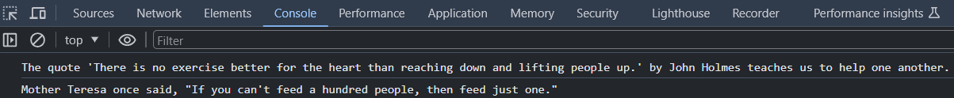  
  
**Q.7 Check if typeof '10' is exactly equal to 10. If not make it exactly equal?** 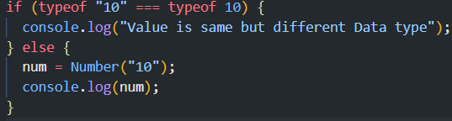

**Q.8 Write a JavaScript Program to find the area of a triangle?  
  
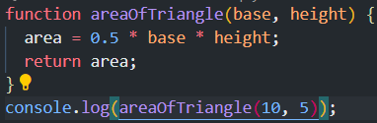  
output : 25  
  
Q.9 Write a JavaScript program to calculate days left until next Christmas?  
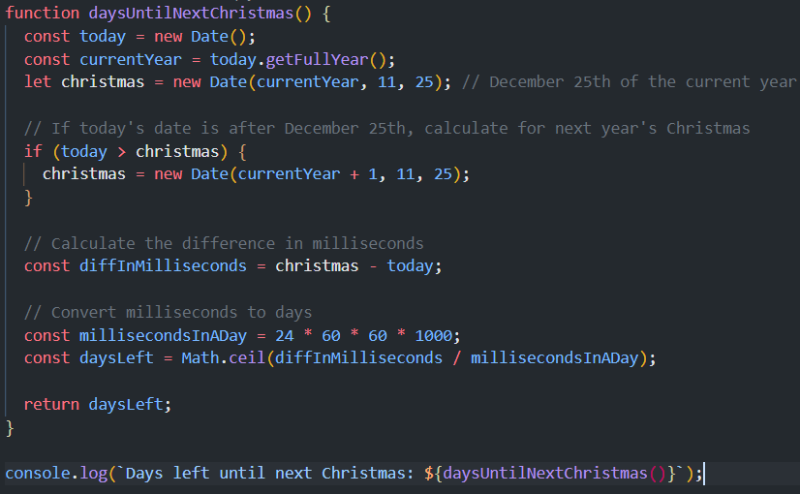**

**Q.10 What is Condition Statement?**-A conditional statement in programming is a feature that performs different actions or computations based on whether a specified Boolean condition evaluates to true or false. Conditional statements are essential in controlling the flow of a program.  
  
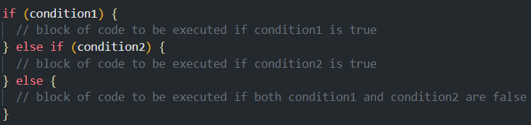

**Q.11 Find circumference of Rectangle formula: C = 4 * a ? (it’s rectangle so formula will be (2*(length+width)))**

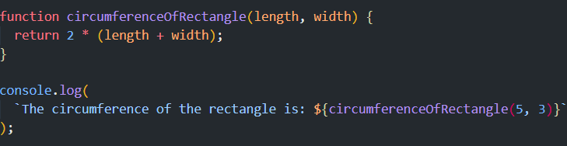

Q.12 WAP to convert years into days and days into years?

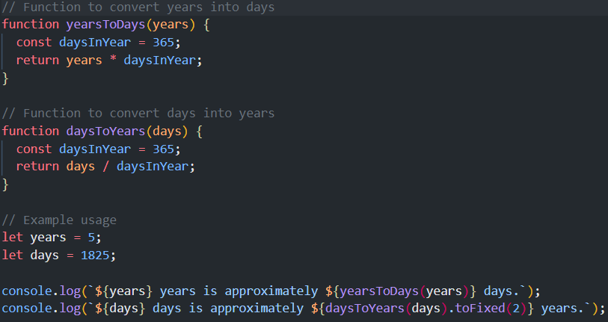

**Q.13 Convert temperature Fahrenheit to Celsius? (Conditional logic Question)**

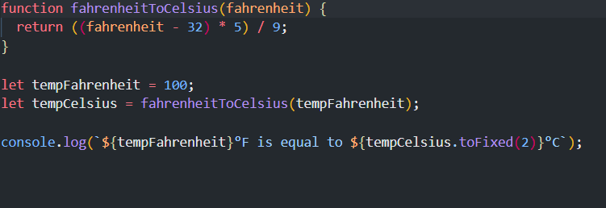

**Q.14 Write a JavaScript exercise to get the extension of a filename.?**

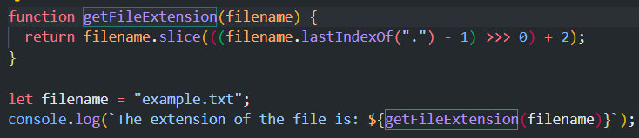

**Q.15 What is the result of the expression (5 > 3 && 2 < 4)?**



**Q.16 What is the result of the expression (true && 1 && "hello")?   
**

**Q.17 What is the result of the expression true && false || false && true?   
**

**Q.18 What is a Loop and Switch Case in JavaScript define that ?**Loop

-A loop is a programming construct that repeats a block of code as long as a specified condition is true.

Example of a for loop: 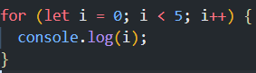

Switch Case

* A switch statement evaluates an expression and matches the expression's value to a case label, executing the associated block of code.

Example:

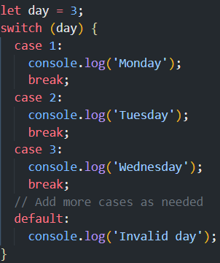

**Q.19 What is the use of is Nan function?**-isNaN is used to determine if a value is NaN (Not-a-Number). It returns true if the value is NaN, otherwise false.

Example:  
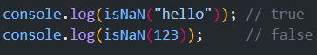

**Q.20 What is the difference between && and || in JavaScript?**-&& (Logical AND) returns true if both operands are true.

|| (Logical OR) returns true if at least one of the operands is true.



**Q.21 What is the use of Void (0)?**-void(0) is often used to prevent a link from navigating to a new page. It evaluates the expression and returns undefined.

**Q.22 Check Number Is Positive or Negative in JavaScript?   
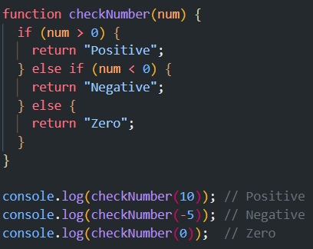**

**Q.23 Find the Character Is Vowel or Not ?   
  
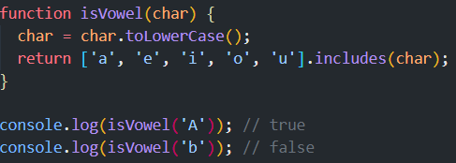**

**Q.24 Write to check whether a number is negative, positive or zero?   
**

**Q.25 Write to find number is even or odd using ternary operator in JS?   
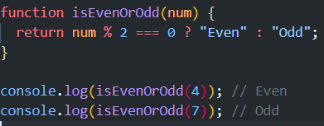**

**Q.26 Write find maximum number among 3 numbers using ternary operator in JS?  
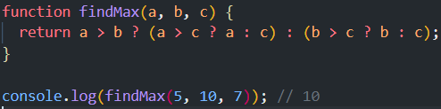**

**Q.27 Write to find minimum number among 3 numbers using ternary operator in JS?   
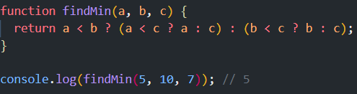**

**Q.28 Write to find the largest of three numbers in JS?   
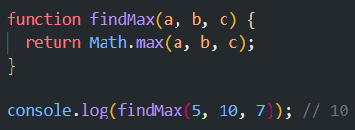**

**Q.29 Write to show**

**i. Monday to Sunday using switch case in JS?  
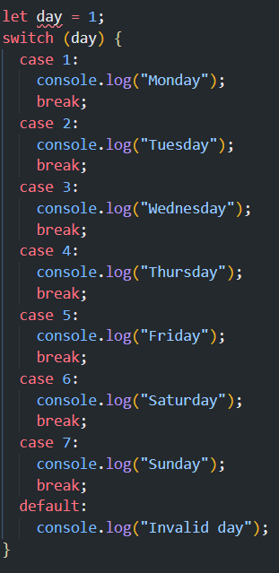**

**ii. Vowel or Consonant using switch case in JS?**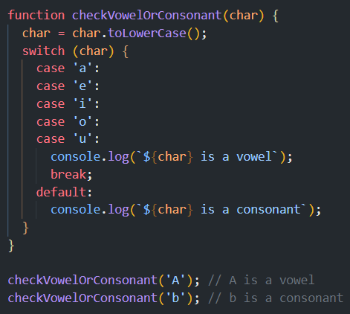

**(Conditional looping logic Question)**

**Q.30 What are the looping structures in JavaScript? Any one Example?**JavaScript provides several looping structures, including:

- for loop

- while loop

- do...while loop

- for...in loop (for iterating over object properties)

- for...of loop (for iterating over iterable objects)  
  
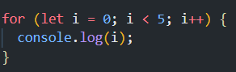  
  
**Q.31 Write a print 972 to 897 using for loop in JS?**

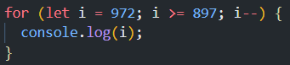

**Q.32 Write to print factorial of given number?   
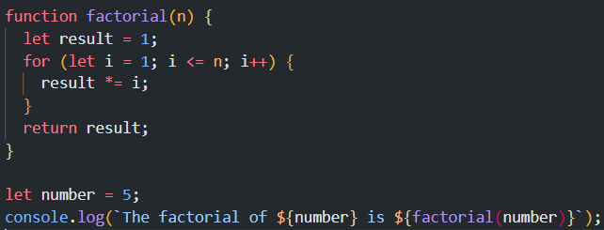**

**Q.33 Write to print Fibonacci series up to given numbers?**

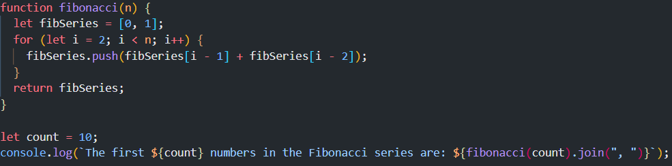

**Q.34 Write to print number in reverse order e.g.: number = 64728 ---> reverse =82746 in JS?**

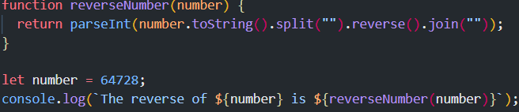

**Q.35 Write a program make a summation of given number (E.g., 1523 Ans: - 11) in JS?**

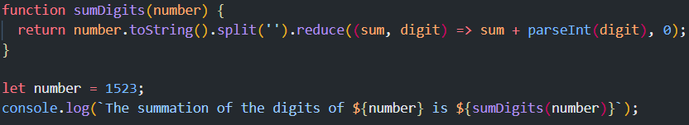

**Q.36 Write a program you have to make a summation of first and last Digit. (E.g., 1234 Ans: - 5) in JS?**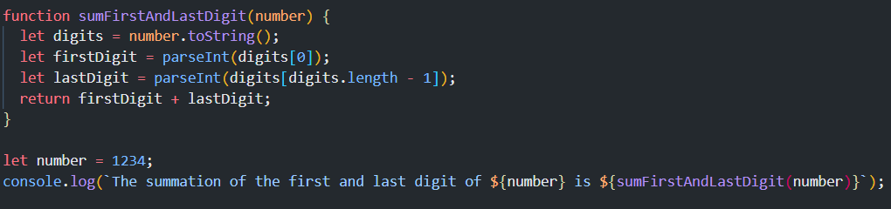

**Q.37 Use console.log() and escape characters to print the following pattern in JS?**

**1 1 1 1 1**

**2 1 2 4 8**

**3 1 3 9 27**

**4 1 4 16 64**

**5 1 5 25 125**



**Q.38 Use pattern in console.log in JS?**

**1)**

**1**

**1 0**

**1 0 1**

**1 0 1 0**

**1 0 1 0 1   
  
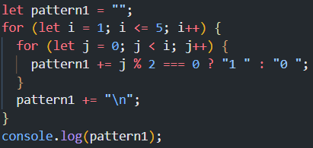**

**2)**

**A**

**B C**

**D E F**

**G H I J**

**K L M N O  
  
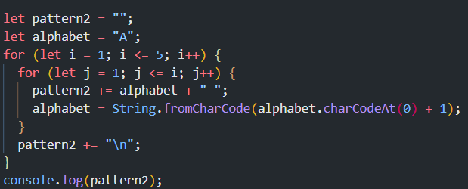**

**3)**

**1**

**2 3**

**4 5 6**

**7 8 9 10**

**11 12 13 14 15  
  
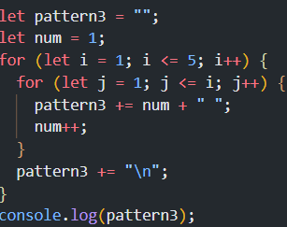**

**4)**

**\***

**\* \***

**\* * \***

**\* * * \***

**\* * * * *  
  
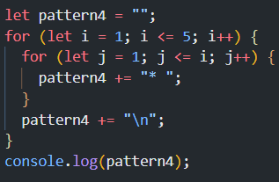**

**Q.39 Accept 3 numbers from user using while loop and check each numbers palindrome?  
  
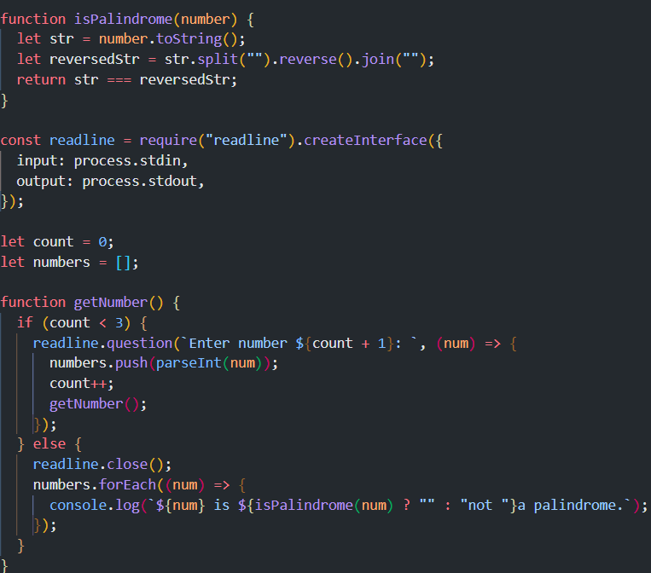   
  
(Array and object Question)**

**Q.40 Write a JavaScript Program to display the current day and time in the following format.**

**Sample Output: Today is Friday. Current Time is 12 PM: 12 : 22 2 ?  
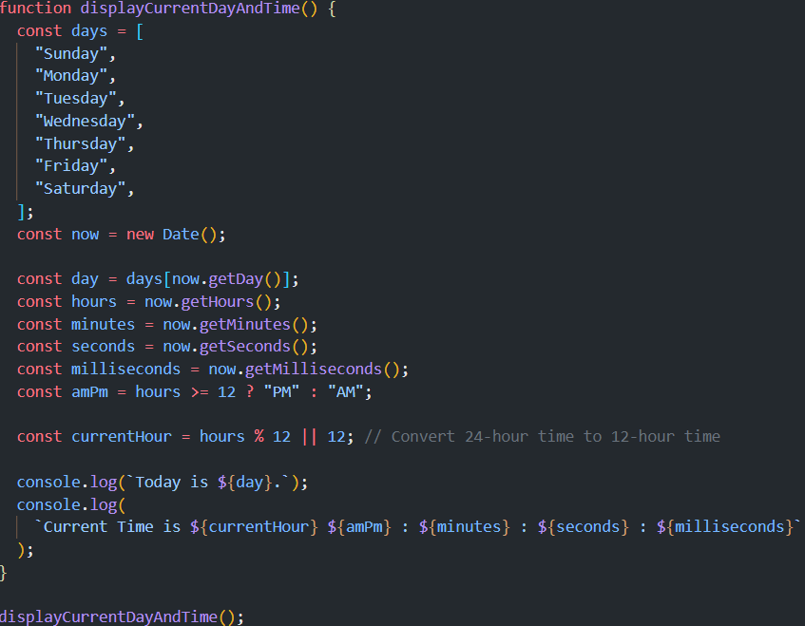**

**Q.41 Write a JavaScript program to get the current date?   
**

**Q.42 Write a JavaScript program to compare two objects?   
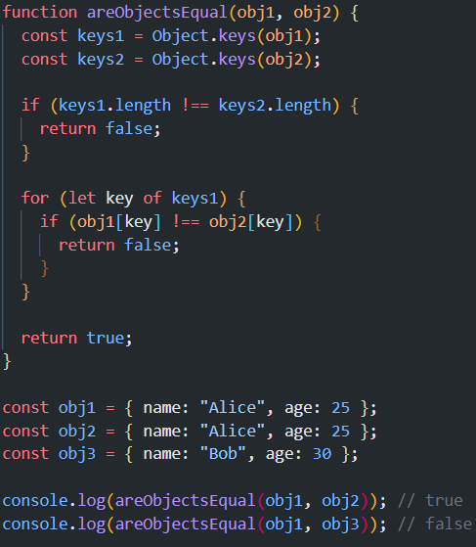**

**Q.43 Write a JavaScript program to convert an array of objects into CSV string?**

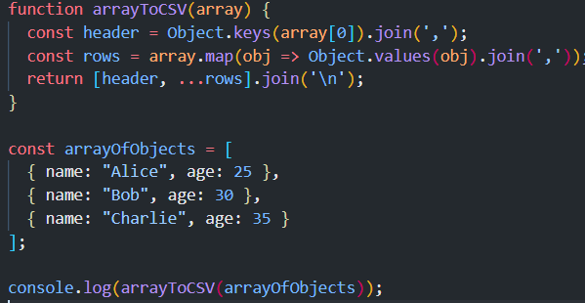

**Q.44 Write a JavaScript program to capitalize first letter of a string?**

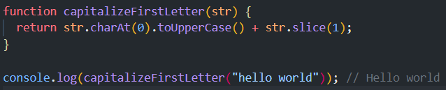

**Q. 45 Write a JavaScript program to determine if a variable is array?**

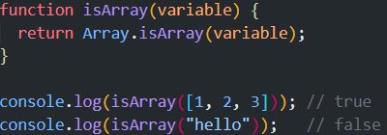

**Q.46 Write a JavaScript program to clone an array?**

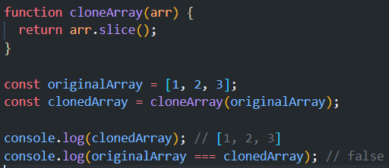

**Q.47 What is the drawback of declaring methods directly in JavaScript objects?**

-Declaring methods directly in objects can lead to higher memory usage, as each object will have its own copy of the method. This is inefficient, especially if multiple objects use the same method. Using prototypes or classes can mitigate this by sharing methods among instances.

**Q.48 Print the length of the string on the browser console using console.log()?**



**Q.49 Change all the string characters to capital letters using toUpperCase() method?**



**Q.50 What is the drawback of declaring methods directly in JavaScript objects?**

**-Same As Q-47**

**Q.51 Write a JavaScript program to get the current date. Expected Output : mm-dd-yyyy,**

**mm/dd/yyyy or dd-mm-yyyy, dd/mm/yyyy?**

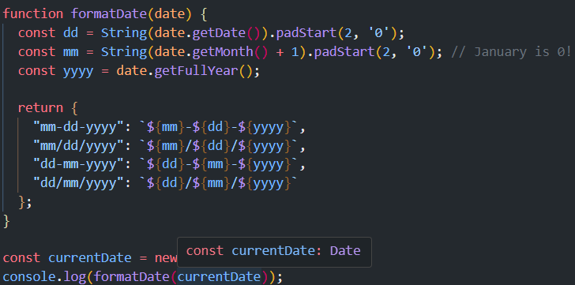

**Q.52 Use indexOf to determine the position of the first occurrence of a in 30 Days Of**

**JavaScript?**

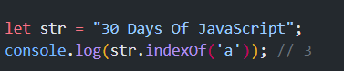

**Q,53 Use lastIndexOf to determine the position of the last occurrence of a in 30 Days Of**

**JavaScript?**

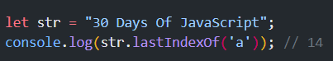

**Q.54 Form Validtion in JS?**

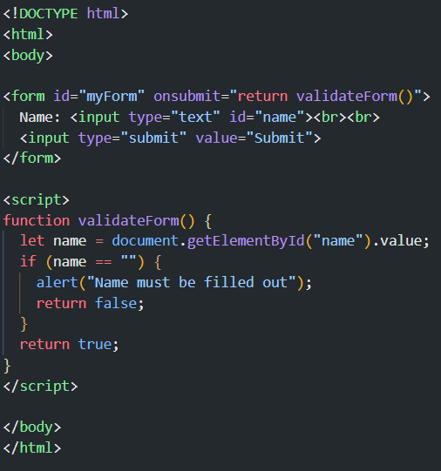

**Q.55 Form in Email, number, Password, Validation?   
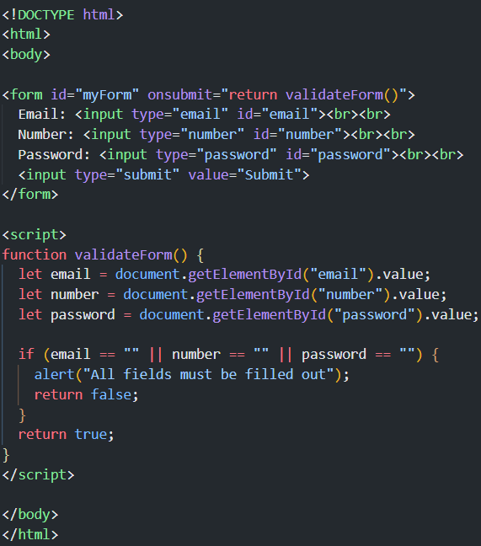**

**Q.56 Dynamic Form Validation in JS?**

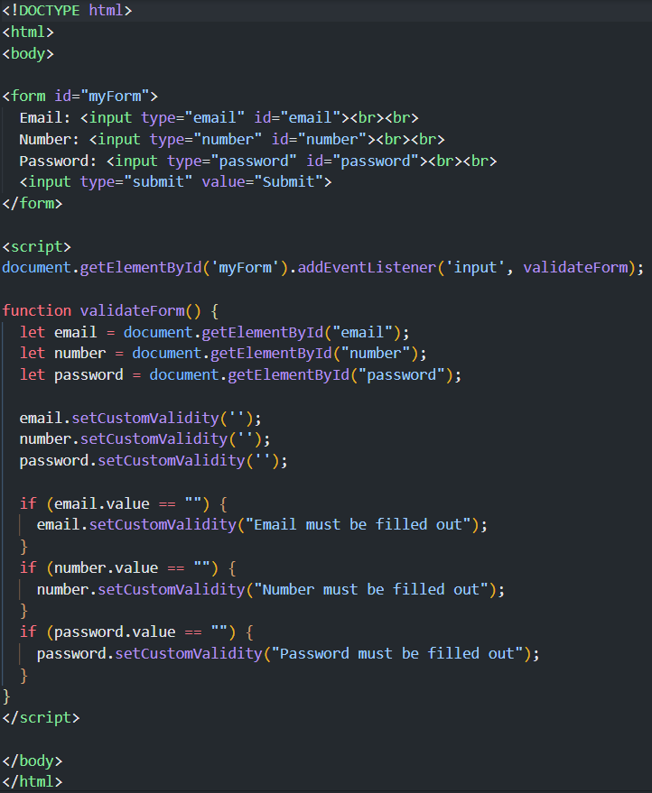

**Q.57 how many type of JS Event? How to use it?**JavaScript events include:

* **Mouse Events**: click, dblclick, mouseover, mouseout, mousedown, mouseup, mousemove
* **Keyboard Events**: keydown, keyup, keypress
* **Form Events**: submit, change, focus, blur
* **Window Events**: load, resize, scroll, unload  
    
  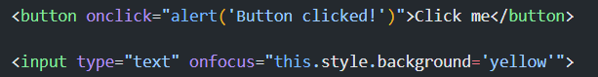

**Q.59 What is Bom vs Dom in JS?**

-**BOM (Browser Object Model)**: Represents the browser window and allows control over browser interactions (e.g., window, navigator, screen, location, history).

-**DOM (Document Object Model)**: Represents the structure of the HTML document as a tree of objects. It allows manipulation of HTML elements and attributes.

**Q.60 Array vs object defences in JS?**

**-Arrays**: Ordered collections of elements, indexed by numeric indices. Used for lists of items.

**let arr = [1, 2, 3];**

-Objects**: Collections of key-value pairs, where keys are strings (or symbols) and values can be of any type. Used for storing data with named properties.**

**let obj = { name: "Alice", age: 25 };**

**Q.61 Split the string into an array using split() Method?**

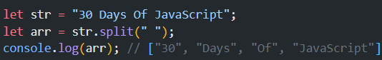

**Q.62 Check if the string contains a word Script using includes() method?   
**

**Q.63 Change all the string characters to lowercase letters using toLowerCase() Method.**



**Q.64 What is Character at index 15 in ’30 Days of JavaScript’ string? Use charAt() method.**



**Q.65 copy to one string to another string in JS?**

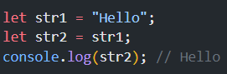

**Q.66 Find the length of a string without using libraryFunction?**

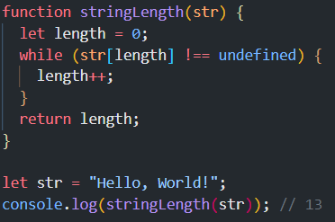

**• What is JavaScript?**

**-** JavaScript is a high-level, dynamic, object oriented, and interpreted programming language. It is widely used for web development to create interactive and dynamic web pages.

**• What is the use of isNaN function?  
-**  isNaN() function determines whether a value is an illegal number (Not-a-Number). It returns true if the value is NaN, otherwise it returns false.

**• What is negative Infinity?**-Infinity is a special value in JavaScript that represents a value less than any other number. It is returned when a negative number exceeds the lower limit of the floating-point numbers.

**• Which company developed JavaScript?**

**-**JavaScript was developed by Netscape Communications Corporation, with Brendan Eich being the original creator.

**• What are undeclared and undefined variables?**

**-Same as Q5**

**• Write the code for adding new elements dynamically?  
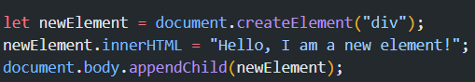**

**• What is the difference between ViewState and SessionState?  
-** ViewState: Used to preserve page and control values between postbacks within the same web page. It is specific to ASP.NET.

SessionState: Used to store user-specific data that can be accessed across multiple pages within a web application session.

**• What is === operator?**- The === operator checks for both value and type equality between two variables. It is known as the strict equality operator.

**• How can the style/class of an element be changed?**

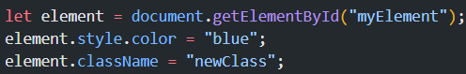

**• How to read and write a file using JavaScript?  
-** In a browser environment, JavaScript cannot directly read/write files on the client-side due to security reasons. However, you can use the File API for reading files and user-initiated downloads for writing files. In a Node.js environment, you can use the fs module.

**• What are all the looping structures in JavaScript?**

**-** for loop

- while loop

- do...while loop

- for...in loop

- for...of loop

**• How can you convert the string of any base to an integer in JavaScript?  
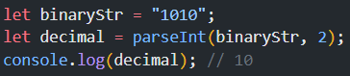**

**• What is the function of the delete operator?  
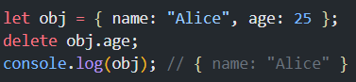**

**• What are all the types of Pop up boxes available in JavaScript?  
-** alert()

- confirm()

- prompt()

**• What is the use of Void (0)?**

void(0) is often used to prevent the default behavior of an anchor tag (<a>) when it's clicked, while still allowing the onclick event to be triggered.

**• How can a page be forced to load another page in JavaScript?  
-** window.location.href = "https://www.example.com";

**• What are the disadvantages of using innerHTML in JavaScript?**- Can lead to security risks (XSS attacks) if not used carefully.

- Overwrites the existing DOM content, which can lead to loss of event listeners and other associated data.

- Can cause performance issues when manipulating large chunks of the DOM.